**Woo commerce to power office Documentation**

**Step 1:** upload plug-in zip file 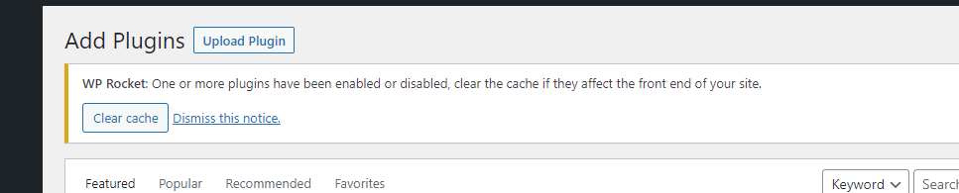

**Step 2:  
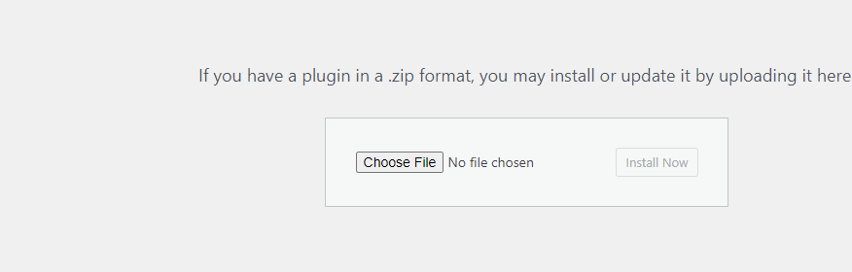  
Step 3:** upload plug-in zip file activate plugin and go to plugin setting Add power office client and secret key make basic auth mention below.

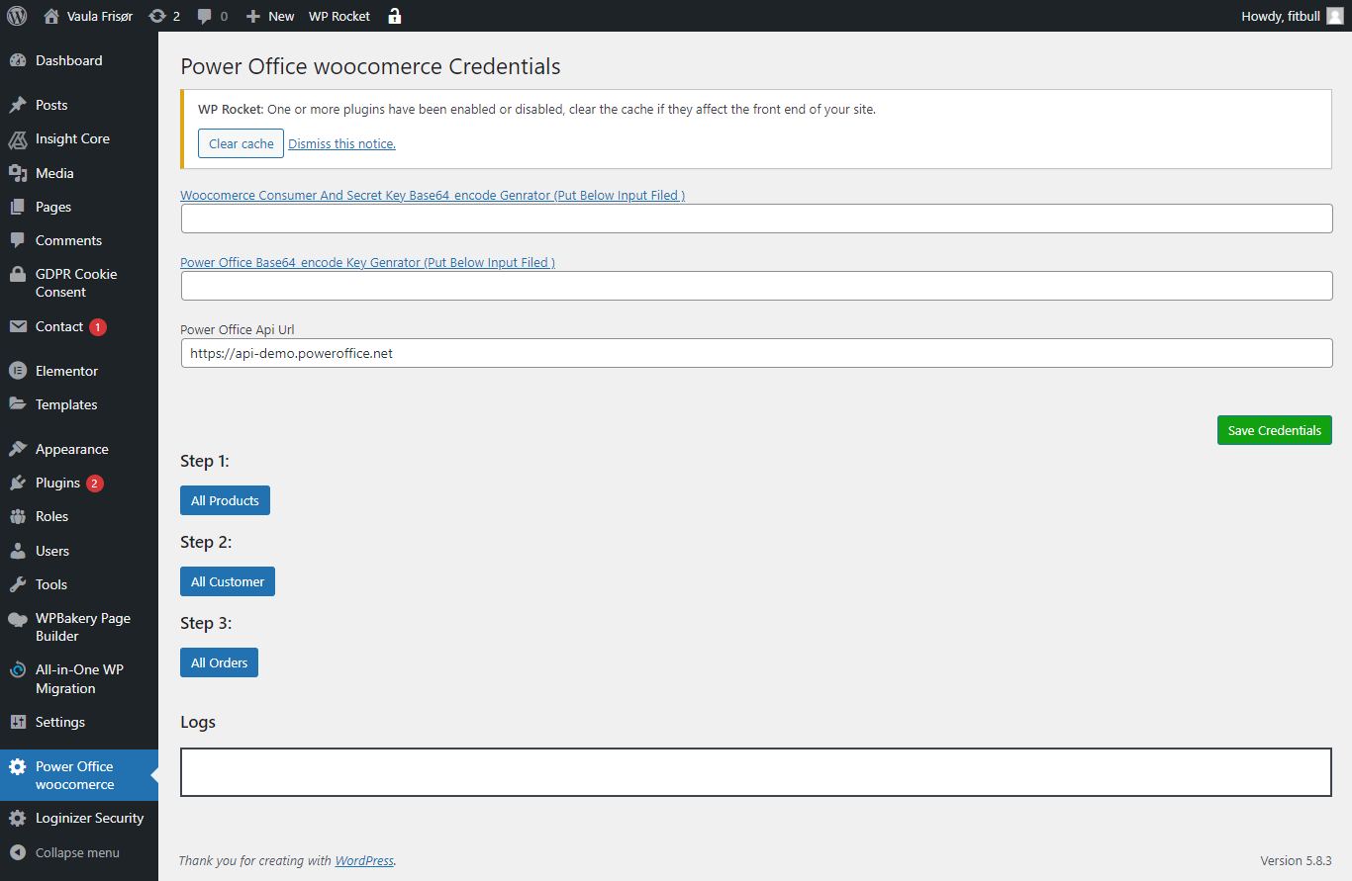

**Step 4:** add power office api auth url and add woo commerce rest api key and power office key make basic authentication .we import all product orders and customers. when place order add product and create customer plugin automatically trigger this .



